Project-HW4-Checkpoint 2 (1 p)

Fall 2025

Instructions

Keep making progress on your project plan and cover the following areas:
- Organizational Chart
- Network Diagram

Team Number and Project Title: Team 4 and Indoor Farming Pods for Urban Homes

Names of students who actively worked on this assignment (think of it as a mini peer review):
- Mohit Athipedu
- Shamsheer Hussain
- Ashwini Mahadevaswamy
- Madison Rogers
- Danyelle Veillard

Checkpoint 2

- 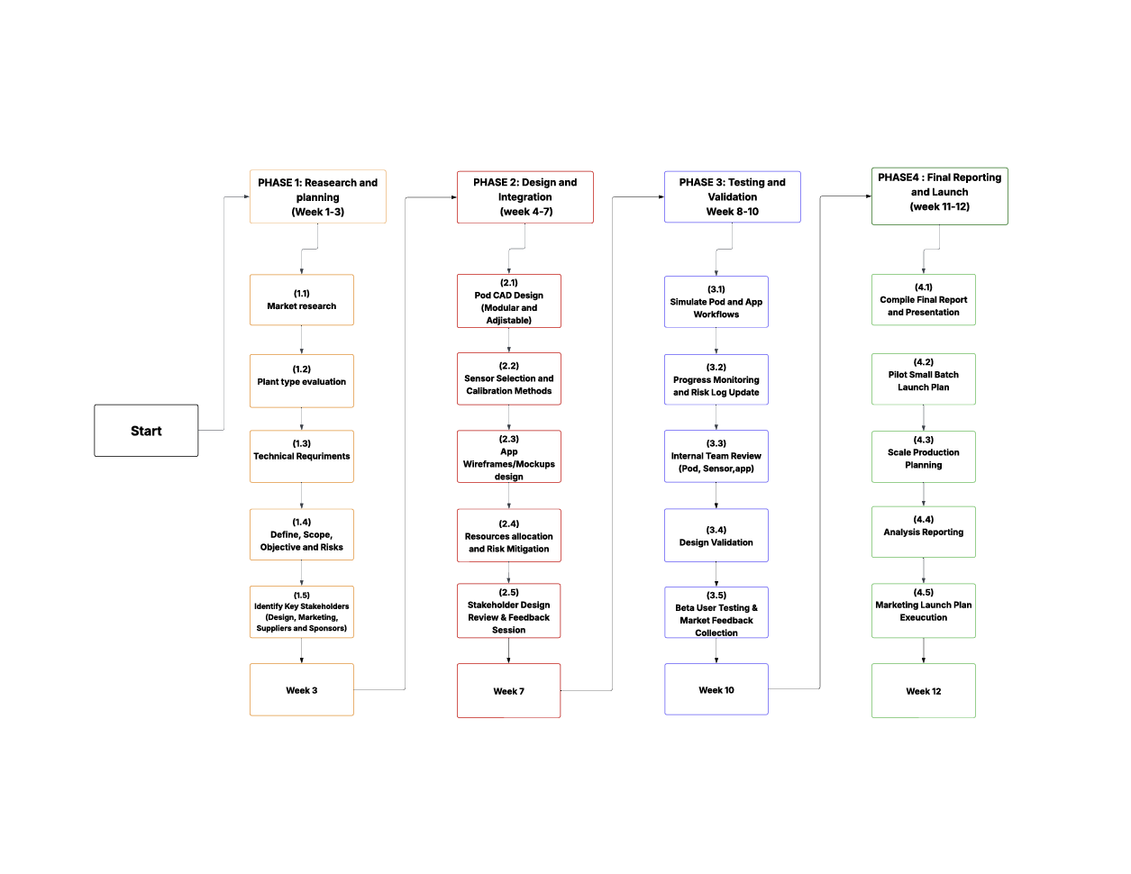Organizational Structure (0.5 p

- 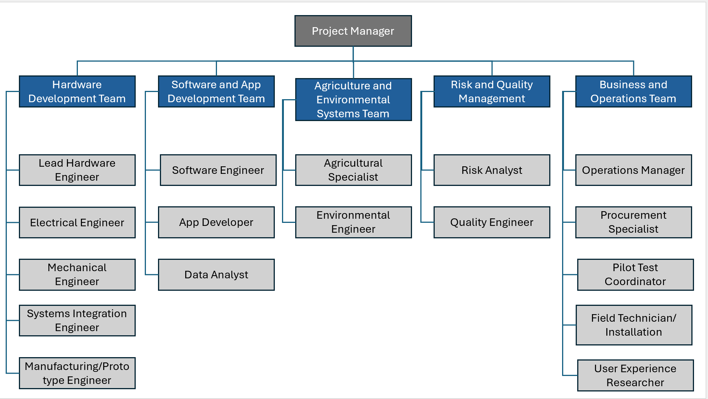Network Diagram (0.5 p)

